STUDY MATERIAL 1 Module -III ECONOMICS HONOURS SEMESTER –I CC 1-1 2019-20
Supply is the quantity of a product that a producer is willing and able to supply onto the market at a given price in a given time period
The law of supply - as the price of a product rises, so businesses expand supply to the market. A supply curve shows a relationship between price and how much a firm is willing and able to sell

The Law of Supply
As mentioned in the introduction, a man of normal intellect always prefers to increase his profit. Talking about the suppliers, when a supplier gets more price for his supply, the normal behavior would be to increase the supply, in order to extract greater profits. This is the law of supply.
Technically, the law of supply states that other factors remaining constant, the quantity of a good produced and offered for sale would increase with an increase in its price and decrease as the price falls.
Thus the law of supply acts as a bridge between the supply of a commodity and its price. Further, we can say that there is a direct relationship between the supply of a commodity and its price.
Again, this law is a result of common sense, as at higher prices a supplier would be looking at greater profit margins and hence it acts as an incentive for increasing the supply.
This law is true for a majority of day-to-day occurrences of supply. However, there are some exceptions to the law of supply. The supply of labor at high wages, for example, decreases instead of increasing.
This is because an employer pays more only when you possess a skill which is not so common. Thus, the supply depends upon the phenomenon under consideration and the extent to which supply can be altered.
Further, the behavior of supply is also the slave of time, for obvious reasons. When talking about short-run, we can play with supply only up to a certain extent, permissible under the short time frame.
On the contrary, in the long run, changes on a large scale become a part of the equation allowing us to alter the supply to a greater extent. Below, is the graphical representation of the law of supply, the supply curve.
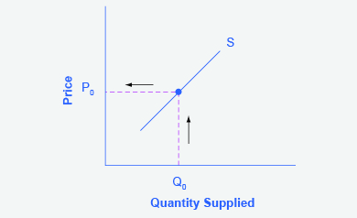

Explaining the Law of Supply
There are three main reasons why supply curves are drawn as sloping upwards from left to right giving a positive relationship between the market price and quantity supplied:
- The profit motive: When the market price rises following an increase in demand, it becomes more profitable for businesses to increase their output
- Production and costs: When output expands, a firm's production costs tend to rise, therefore a higher price is needed to cover these extra costs of production. This may be due to the effects of diminishing returns as more factor inputs are added to production.
- New entrants coming into the market: Higher prices may create an incentive for other businesses to enter the market leading to an increase in total supply.

Effects on Supply Curve
We are now aware of the various determinants of supply curves. An alteration of any of these factors has effects on the supply curve. We classified the determinants of supply into two categories- price and factors other than price.
Interestingly, the incidence of the alterations in determinants of supply is also categorized into two. The changes in price and factors other than price have varying consequences on the curve. These are classified as the movement along the supply curve and shift in the supply curve.

Movement along the Supply Curve
When the price of a commodity changes, other factors kept constant, the quantity supplied of a commodity changes suitably. This is because of the direct relationship between the two. This is known as a change in quantity supplied. Graphically it causes movement along the supply curve. A change in price either causes supply curves to expand or contract.
If the prices increase, other factors kept constant, there is an increase in the quantity supplied which is referred to as an expansion in supply. Graphically, this is represented as an upward movement along the same supply curve.
Conversely, if the prices decrease, keeping other factors constant, firms tend to decrease the supply. This is referred to as a contraction in supply. Graphically, this is represented as a downward movement along the same supply curve.
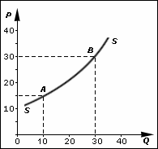

Shifting of the Supply Curve
The factors other than price affect the supply curve in a different manner. These factors cause the supply curve to shift. Of course, this shift is also categorized into two which are- a leftward and rightward shift.
Note that, this shift occurs because the price is constant when studying the effect of other factors on supply. A rightward shift indicates a positive effect on the curve whereas a leftward shift indicates a negative effect on the supply curve. We have already studied the various factors other than price and their relationship with the supply of a commodity. The factors can either have a direct or an inverse relationship with the quantity of commodity supplied.
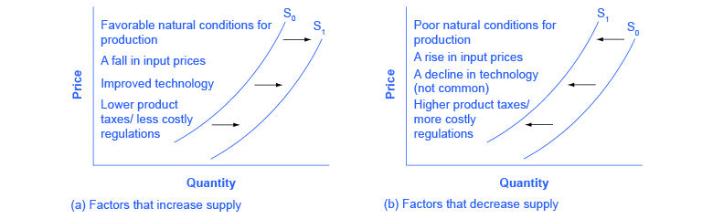

Direct Relationship with supply
Factors like the state of technology have a direct relationship with the supply. In other words, the change in such factors and supply occurs in the same direction. As a result, an increase in such factors leads to a shift in the rightward direction. Conversely, a decrease in such factors causes the curve to shift towards left.

Inverse Relationship with supply
Factors like the price of other goods tend to be in an inverse relationship with the supply of a commodity. Simply put, a change in such factors and supply occurs in opposite direction. A negative change in such factors induces a positive change in supply and vice versa. In effect, an increase in such factors leads to a shift in leftward direction. However, a decrease of such factors causes the supply curve to shift towards the right.

